Lab 1 Lab Report

Team Information

**Lab number:** 1

**Date:** 09/24/2015

**Team Number/Name:** 206

Team Member Responsibilities

**Software Design:** Nadir Carreón

**Hardware Design:** Oscar Morales

**Quality Assurance:** Justin Carlson

**Systems Integrator:** Carmelo Moraila

Hardware

Part 1

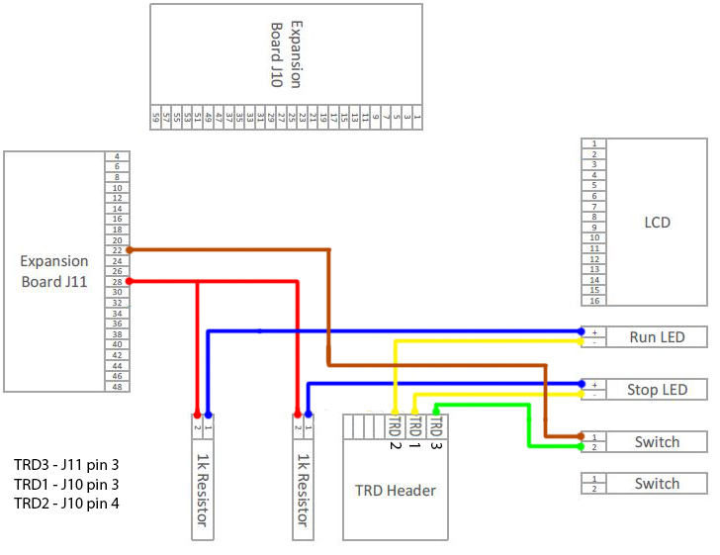

Different colors are used to make the design more easily viewed, but in real connections the rule is as follows: black wires for ground connections, red wires for 5V and green-yellow-blue for signals between components and the board (this on consideration of cables availability).

Part 2

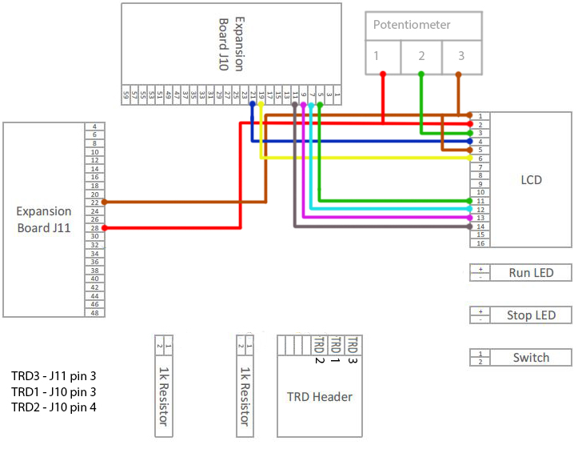

Part 3

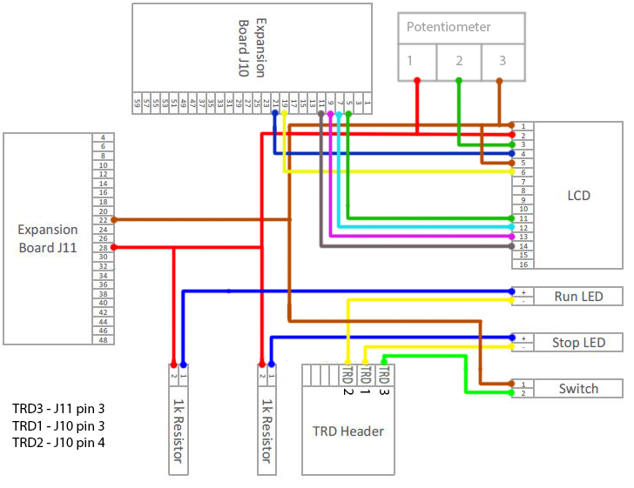

Tests

Part 1

|  |  |  |
| --- | --- | --- |
| Test Name | Tool | Description |
| Continuity Test | Digital Multi-meter | Test all wire connectors, solder joints, and wire-wraps for continuity |
| Power Test | Digital Multi-meter | Test that any created circuits have power correctly flowing |
| Grounding Test | Digital Multi-meter | Test that any switches connected to ground actually ground a powered circuit |
| Component Test | Digital Multi-meter | Test that appropriate pins on the switch are connected |

The components were assembled together in the prototype board and their functionality was tested.

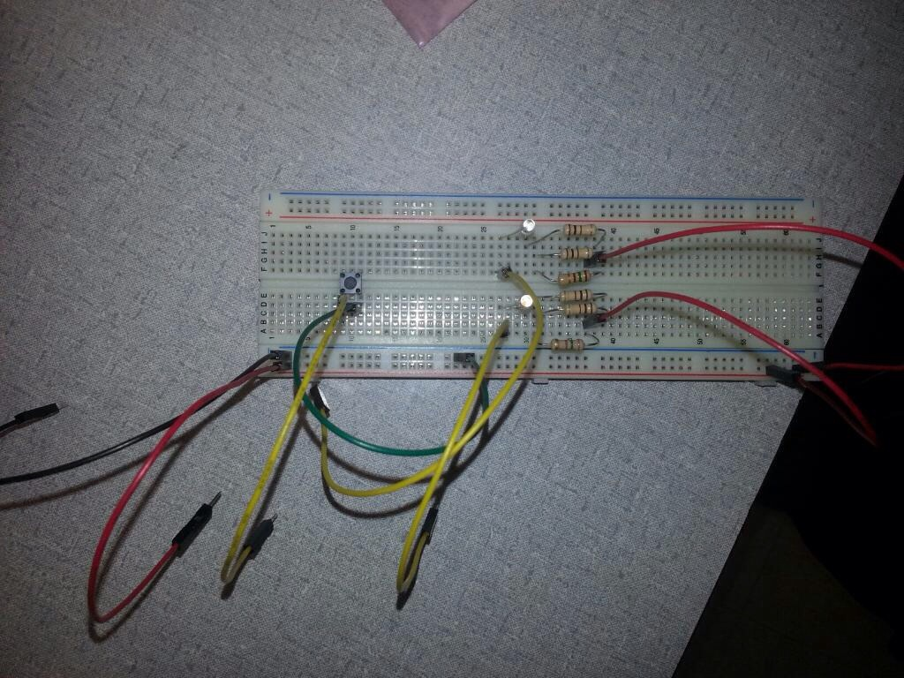

Image 1.1 Components in the prototype board.

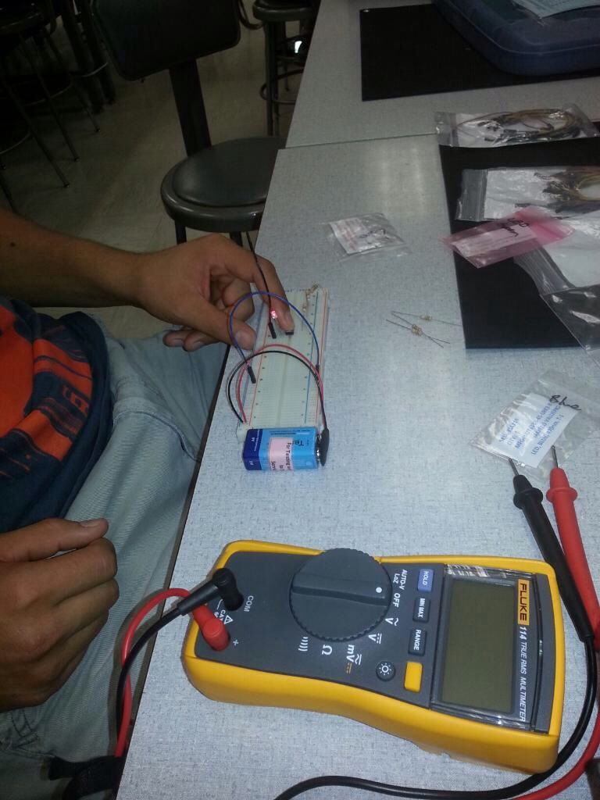

Image 1.2 testing the button and led with an external power source.

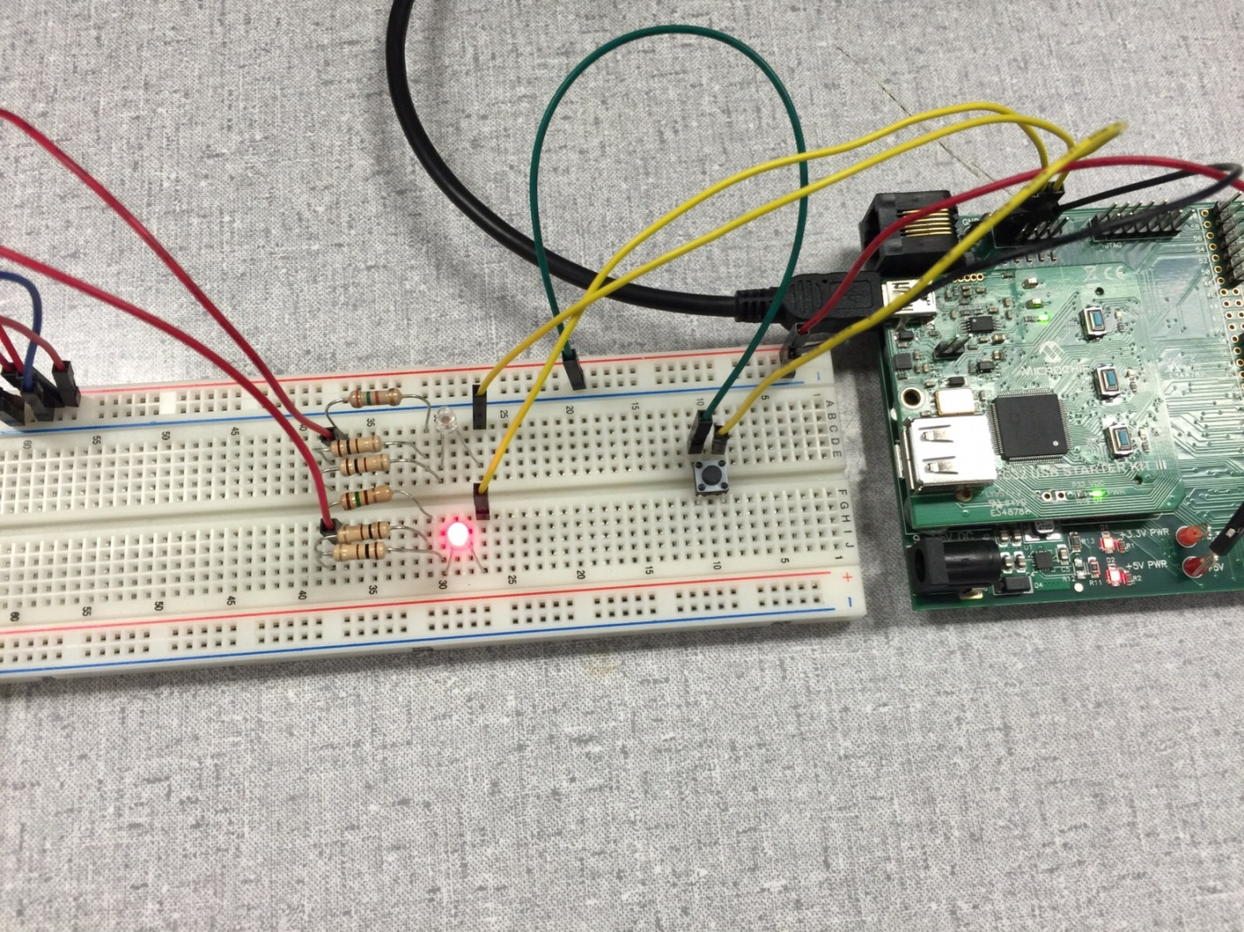

Image 1.3 circuit connection with the board

Part 2

|  |  |  |
| --- | --- | --- |
| Test Name | Tool | Description |
| Continuity Test | Digital Multi-meter | Test all wire connectors, solder joints, and wire-wraps for continuity |
| Power Test | Digital Multi-meter | Test that any created circuits have power correctly flowing |
| Component Test | Digital Multi-meter | Test that appropriate pins on the LCD are connected |
| timerTick Test |  | Test that timerTick indeed ticks at the correct interval |
| Register Test |  | Test that the register configurations for the timer work. |
| displayText Test | “10000” | Test that this function assigned the appropriate register to “10:00:00.” |
| InterruptionTest |  | Test that the interruptions work correctly. |

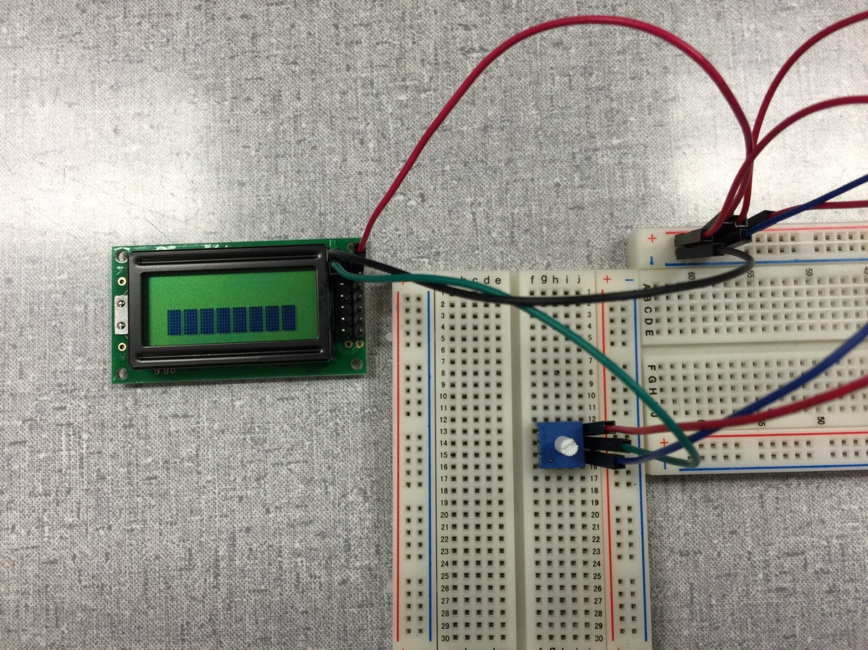

Image 2.1 LCD and potentiometer test

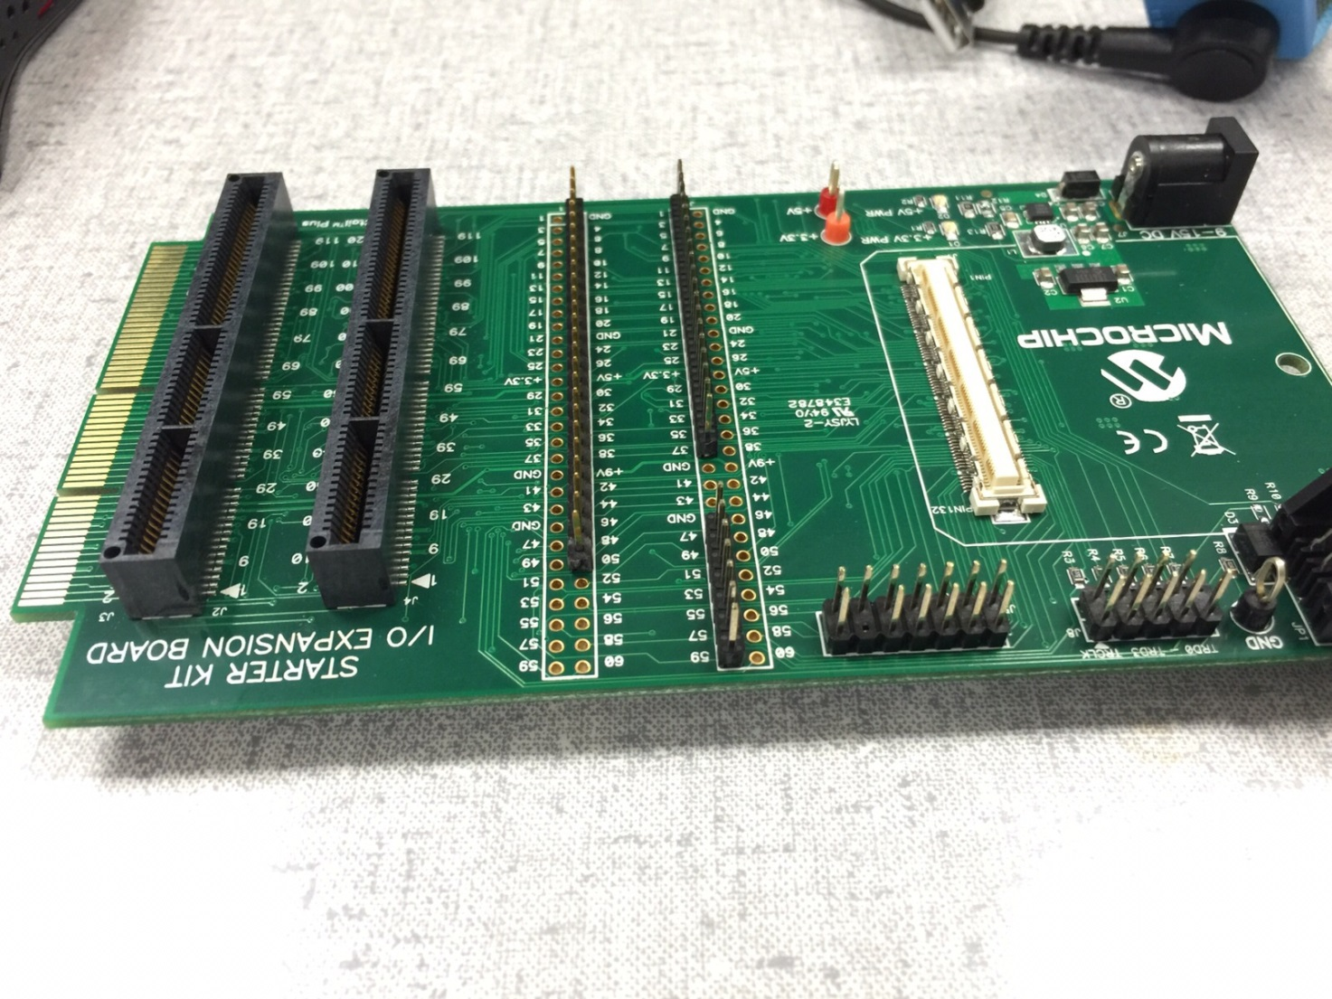

Image 2.2 pin headers soldered to the board, top side

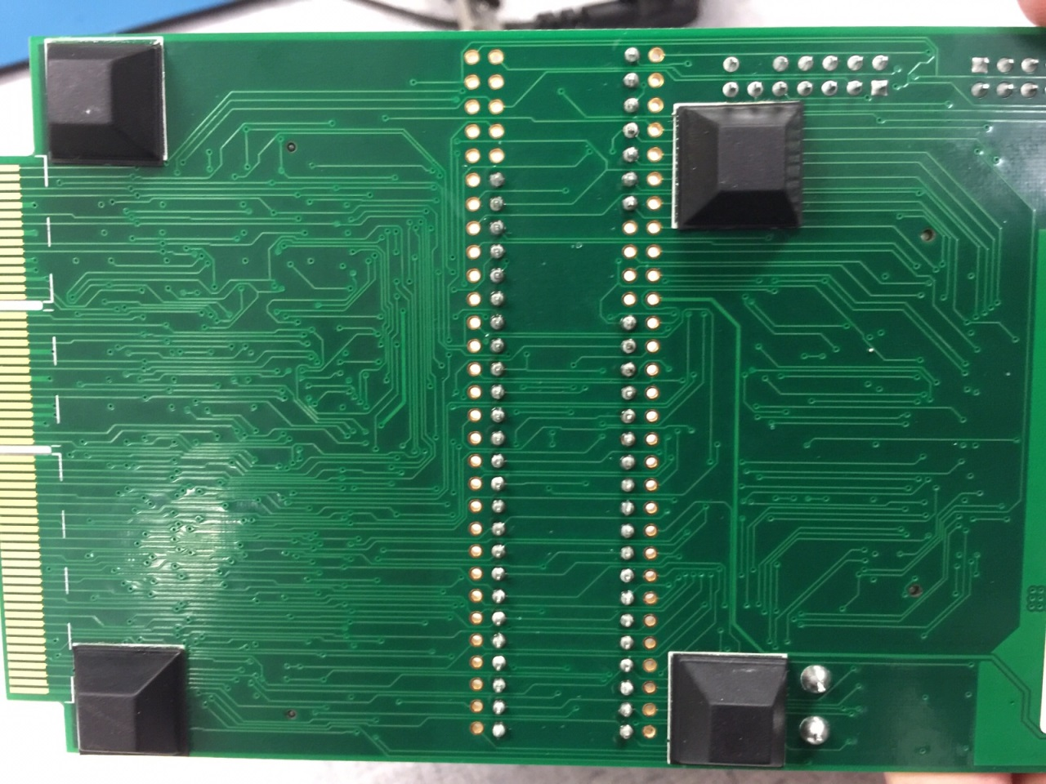

Image 2.3 pin headers soldered to the board, bottom side

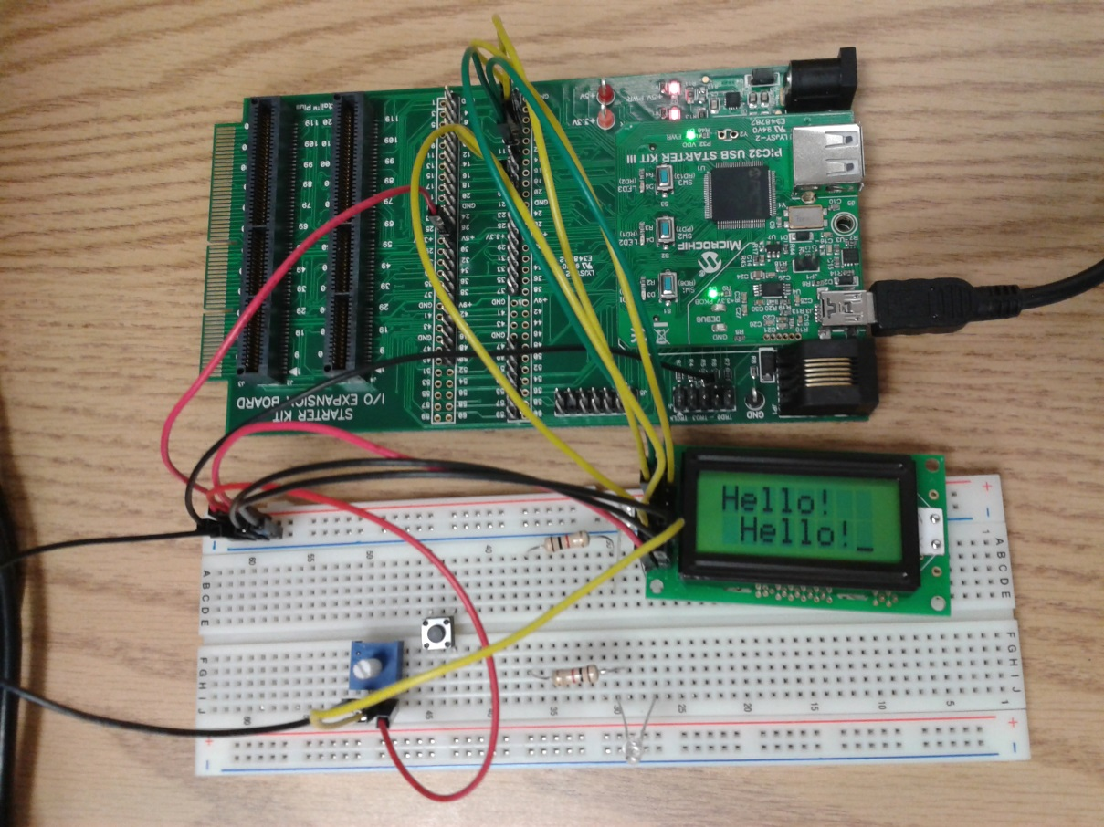

Image 2.4 LCD functionality test

Part 3

|  |  |  |
| --- | --- | --- |
| Test Name | Tool | Description |
| Continuity Test | Digital Multi-meter | Test all wire connectors, solder joints, and wire-wraps for continuity |
| Power Test | Digital Multi-meter | Test that any created circuits have power correctly flowing |
| Grounding Test | Digital Multi-meter | Test that any switches connected to ground actually ground a powered circuit |
| Component Test | Digital Multi-meter | Test that appropriate pins on the switch are connected |
| Quality Test | Jump Wires | Test that every component work, test the leds and buttons using a simple circuit. |
| timerTick Test |  | Test that timerTick indeed ticks at the correct interval |
| Register Test |  | Test that the register configurations for the timer work. |
| displayTime Test | “10000” | Test that this function assigned the appropriate register to “10:00:00.” |
| InterruptionTest |  | Test that the interruptions work correctly. |
| TimerTest |  | Test that the LCD registers the time correctly. |
| ButtonTest |  | Test that the LCD changes from Running to Stopped and vice-versa and that the buttons do their function (start/stop, reset). |

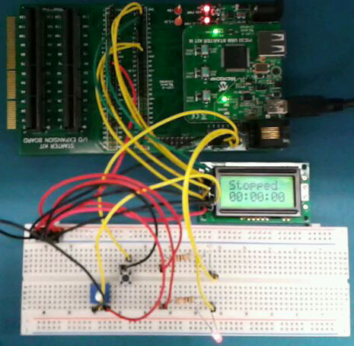

Image 3.1 LCD in stop state

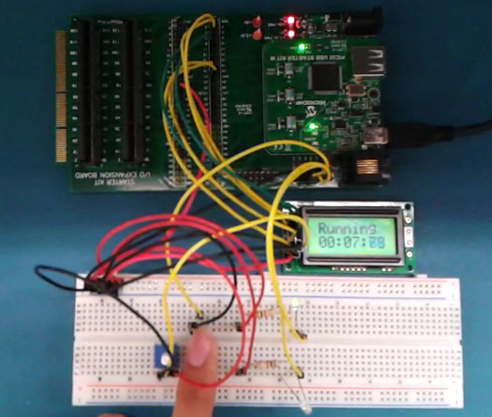

3.1 LCD running test

Software

Part 1

|  |  |
| --- | --- |
| Device: | Register(s): |
| **Digital I/O** | TRD1 – PORTGbits.RG12, TRISGbits.RG12  TRD2 – PORTGbits.RG14, TRISGbits.RG14  TRD3 – PORTAbits.RA7, TRISAbits.RA7 |

FSM:

Sw1=1

Wait release 1

Debounce press 1

Wait press 1

Sw1=1

LED run=1 LED stop=0

Debounce release 1

Debounce release 2

LED Stop

Sw1=1

Wait release 2

Debounce press 2

LED run=0 LED stop=1

Sw1=1

Part 2

|  |  |
| --- | --- |
| Device: | Register(s): |
| **Digital I/O** | LCD_D4 - LATEbits.LATE7  LCD_D5 - LATEbits.LATE5  LCD_D6 - LATEbits.LATE3  LCD_D7 - LATEbits.LATE1  LCD_RS - LATCbits.LATC4  LCD_E - LATCbits.LATC2  TRIS_D7 - TRISEbits.TRISE1  TRIS_D6 - TRISEbits.TRISE3  TRIS_D5 - TRISEbits.TRISE5  TRIS_D4 - TRISEbits.TRISE7  TRIS_RS - TRISCbits.TRISC4  TRIS_E - TRISCbits.TRISC2 |

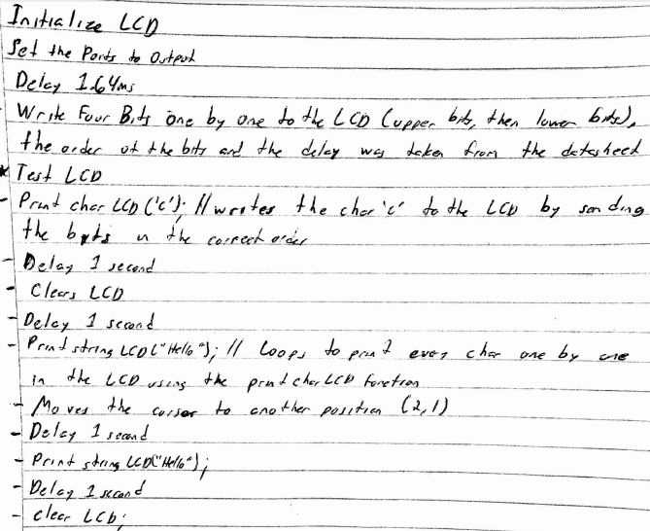

Part 3

|  |  |
| --- | --- |
| Device: | Register(s): |
| **Digital I/O** | TRD1 – PORTGbits.RG12, TRISGbits.RG12  TRD2 – PORTGbits.RG14, TRISGbits.RG14  TRD3 – PORTAbits.RA7, TRISAbits.RA7  LCD_D4 - LATEbits.LATE7  LCD_D5 - LATEbits.LATE5  LCD_D6 - LATEbits.LATE3  LCD_D7 - LATEbits.LATE1  LCD_RS - LATCbits.LATC4  LCD_E - LATCbits.LATC2  TRIS_D7 - TRISEbits.TRISE1  TRIS_D6 - TRISEbits.TRISE3  TRIS_D5 - TRISEbits.TRISE5  TRIS_D4 - TRISEbits.TRISE7  TRIS_RS - TRISCbits.TRISC4  TRIS_E - TRISCbits.TRISC2 |

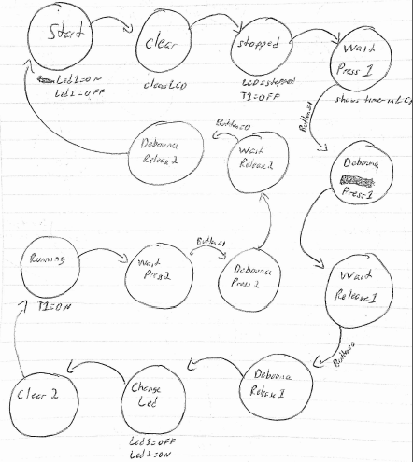

Version Control

